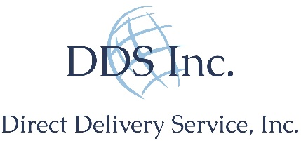

Delivery Driver (Amazon)
Come Join Us!
Our Team is committed to growth, and excited to announce we will be soon be providing delivery services to your local area. DDS, Inc. believes that success comes from our experienced and knowledgeable Team Members, who are committed to providing fast and excellent service. It’s no secret that logistics and transportation of goods industry is one of the largest in the world, but what’s even more important to us is people – both our customers and our Team Members. Join our family – we’re strong and growing, and we need people like you. We’re hiring in your area!
Summary:
This is a physical, fast-paced, outdoor position that involves continual lifting, lowering and carrying packages that typically weigh 5 - 15 lbs. and may weigh up to 70 lbs. This is a performance-based job, and you will be delivering anywhere from 150-200+ packages per day. It requires excellent customer contact skills and a lot of walking.
Under general supervision this position drives the Company Cargo Van over an established route(s) to deliver products. Additionally, this position fulfills all shipping and receiving functions within the warehouse.
Responsibilities:
- Care and responsiveness while driving and delivering packages
- Ability to work independently while engaging with customers as the face of Direct Delivery Services, Inc.
Qualifications/Essential Duties:
- Minimum 21 years of age
- Being eligible to work in the United States
- Stamina to stand and walk for entire work shift
- Strength to lift 70 lbs. of merchandise for loading and delivery
- Maintaining a distribution log or tracking system to record all deliveries made
- Having a valid driver’s license with an acceptable driving record
- Speak and write English (Spanish a plus); communicate effectively and build strong relationships with customers, peers and management
- Driving throughout the metropolitan area using GPS system, maps, and verbal directions
- Flexibility in schedule including evenings, weekends and holidays
- Successfully pass Pre-Employment drug screen and background check
Direct Delivery Services, Inc. is an equal opportunity employer and all qualified applicants will receive consideration for employment without regard to race, color, religion, sex, sexual orientation, gender identity, national origin, disability status, protected veteran status, or any other characteristic protected by law.

